FIRST INTERNAL20MCA241-Data Science Lab(ANSWER SHEET)

2.program to find the reverse of a number
num = 1234
reversed_num = 0

while num != 0:
digit = num % 10
reversed_num = reversed_num * 10 + digit
num //= 10

print("Reversed Number: " + str(reversed_num))
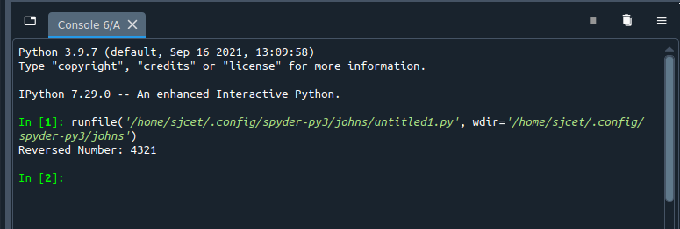

1. Create 2 matrixes X and Y with dimensions 3x3
(i) Perform the operation 7X+ Y3
(ii) Perform the matrix multiplication of x and Y
(iii) Display the diagonal elements and rank of the matrix
CODE:
import numpy as np
x = np.array([[3, 6,2], [5, -10,4],[3, 6,2]])
y = np.array([[9, -18,2], [11, 22,3],[3, 6,2]])
z = x * y
print("Multiply the individual elements of matrix")
print(z)
x = np.array([[3, 6,2], [5, -10,4],[3, 6,2]])
y = np.array([[9, -18,2], [11, 22,3],[3, 6,2]])
z = x.dot(y)
print("matrix multiplication")
print(z)
x = np.array([[3, 6, 9,-18], [5, -10, 15,11], [4,8,12,14]])
print("Sum of diagonal elements of a matrix")
print(np.trace(x))
my_matrix = np.array([[3, 6, 9,-18], [5, -10, 15,11], [4,8,12,14]])
for row in my_matrix:
print(row)
rank = np.linalg.matrix_rank(z)
print("Rank of the given Matrix is : ",rank)
OUTPUT

